Lions Club Car Show

[](https://www.bing.com/images/search?view=detailV2&ccid=M3KL4Mfa&id=D84DE0DACCAB258ECC554DA413AA1A04E8ED4EF1&thid=OIP.M3KL4MfajGj0uPNa9ZSHnQHaG_&mediaurl=http://district322a.org/rsrc/logoes/images/lion4.jpg&exph=203&expw=215&q=black+%26+white+lions+club+logo&simid=608028743578879900&selectedIndex=0)

Hosted by the Delmont & Murrysville Lions Clubs   
Sunday, August 25, 2024 from 11a-4p

Delmont Fire Department, Delmont, PA  
2360 PA-66, Delmont, PA 15626  
Enter from Abbe Place-Not Rt66

Bring your friends, family & neighbors for a fun filled day!! (No Pets)

Rain or Shine  
Donation: $10.00  
Dash Plaques to first 100 ** Trophies ** Basket Raffle & 50/50   
** Food & Drinks available ** Entertainment by DJ Larry

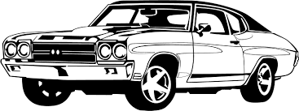

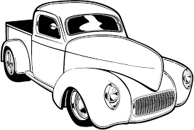

__________________________________________________________________

All Vehicles are Welcome!!

Any questions, please contact the Car Cruise Committee:   
Alice Heasley ([trinjoal@yahoo.com](mailto:trinjoal@yahoo.com) or 724-836-1490)   
Doug Harr ([harrs5@comcast.net](mailto:harrs5@comcast.net) or 724-468-6676)   
Dave Paluselli ([georgiepal@comcast.net](mailto:georgiepal@comcast.net) or 724-357-3550)  
Barb Cseh ([bavcseh35@aol.com](mailto:bavcseh35@aol.com) or 724-733-0071)

All proceeds will benefit The Westmoreland County Food Bank, Four Diamonds (Pediatric Cancer), Pa Lions Beacon Lodge Camp(special needs-children, adults & veterans), and Lions Diabetes Board of Allegheny & Westmoreland County

*Disclaimer: Delmont VFD & the Delmont & Murrysville Lions Clubs cannot be held responsible for any damages to your vehicle during the show.*